# **Assignment 2 (MSIS2503-40134,40153,40170)**

Q1) For each customer who has rented a movie, give customer name, customer_id and rental_id. Write an Equi-Join, a Natural join and an Inner join for Question 1.

* **Screenshot of MYSQL query and results as shown below for Q1): Inner Join**

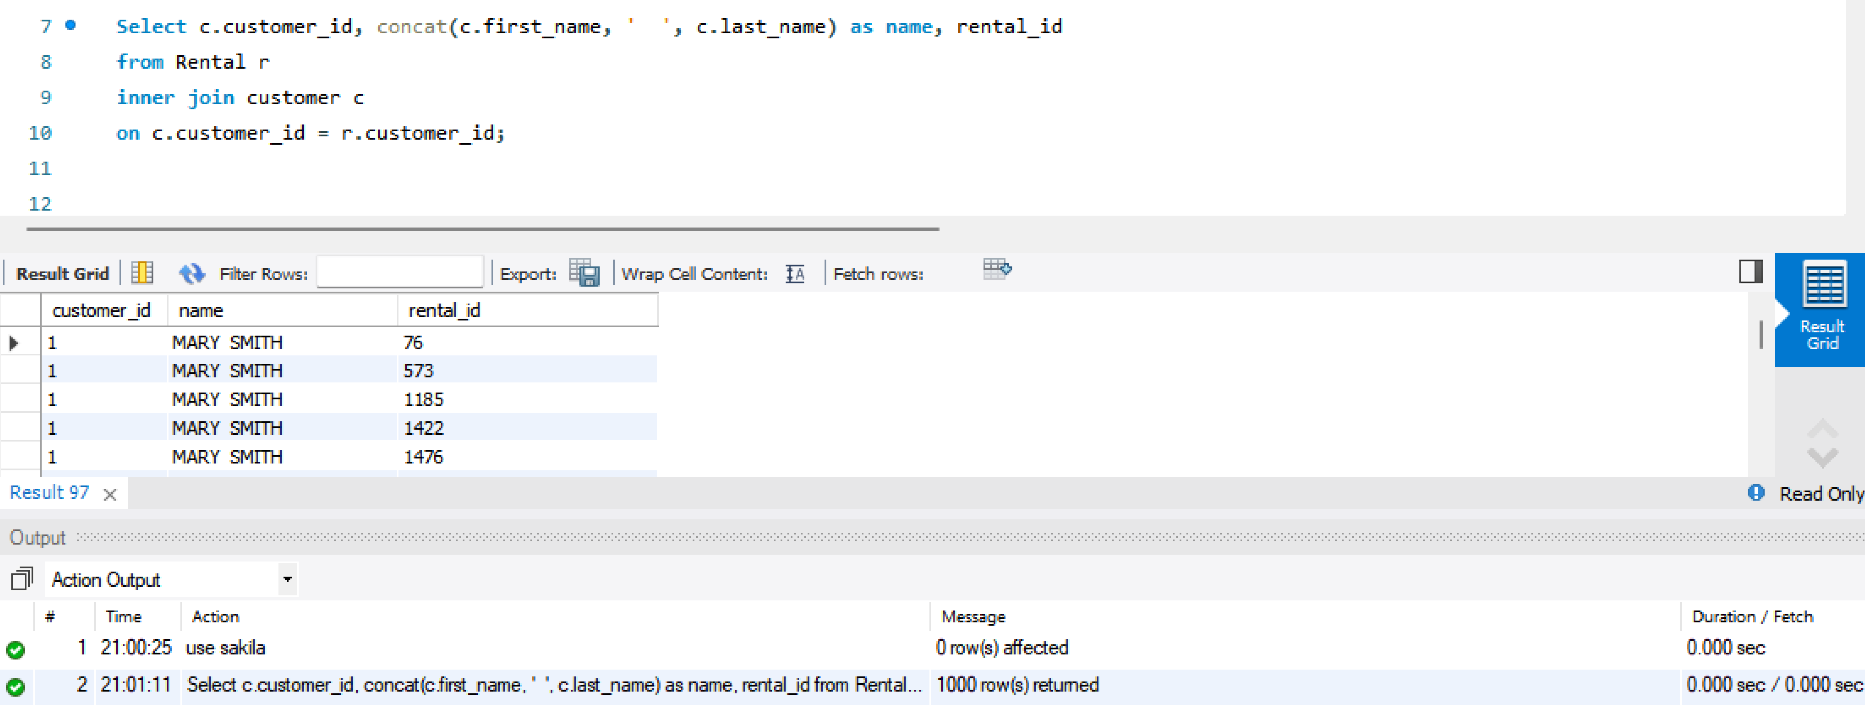

* **Screenshot of MYSQL query & results as shown below for Q1): Equi Join**

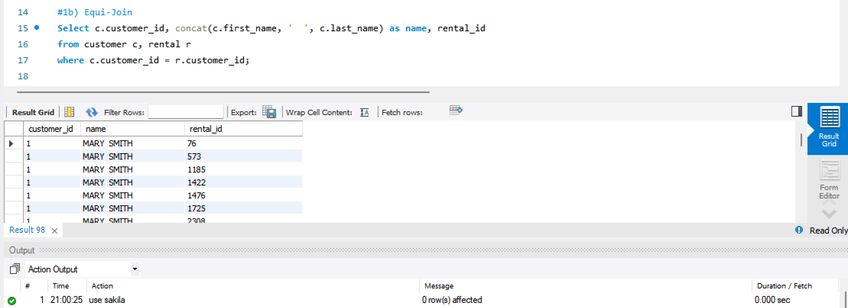

* **Screenshot of MYSQL query & Results as shown below for Q1): Natural Join**

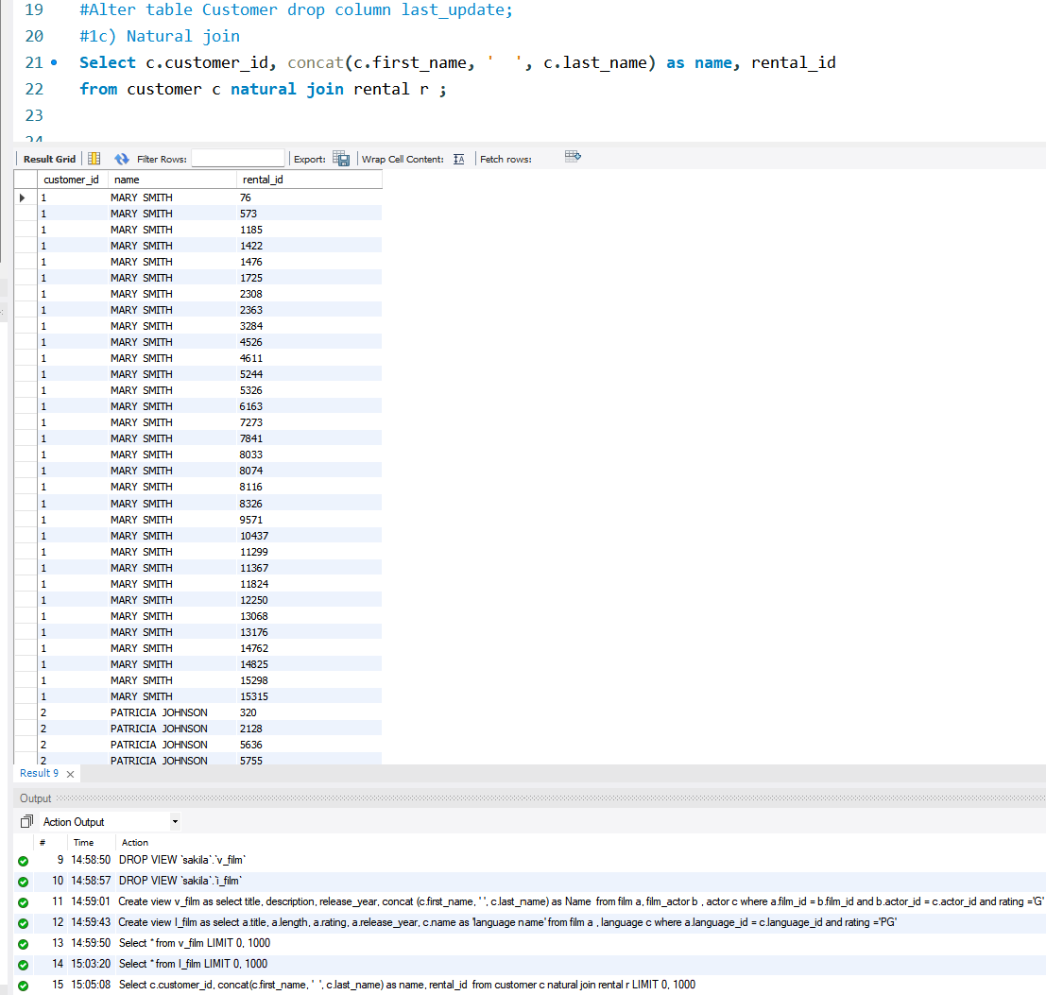

Q2) List the customer_name, ID and rental_id for all customers. Include those customers also who have not rented any movies

* **Screenshot of MYSQL query & results as shown below for Q2):**

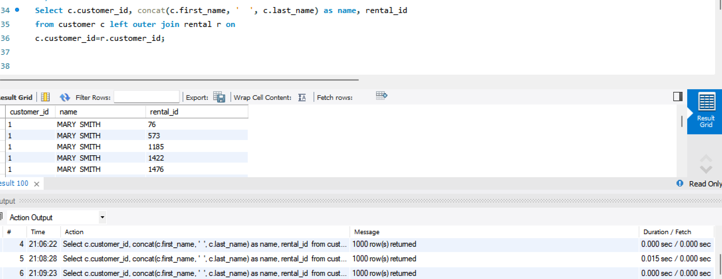

Q3) List out store_id, staff_name and staff_id. Include all staff information irrespective store.

* **Screenshot of MYSQL query & results as shown below for Q3):**

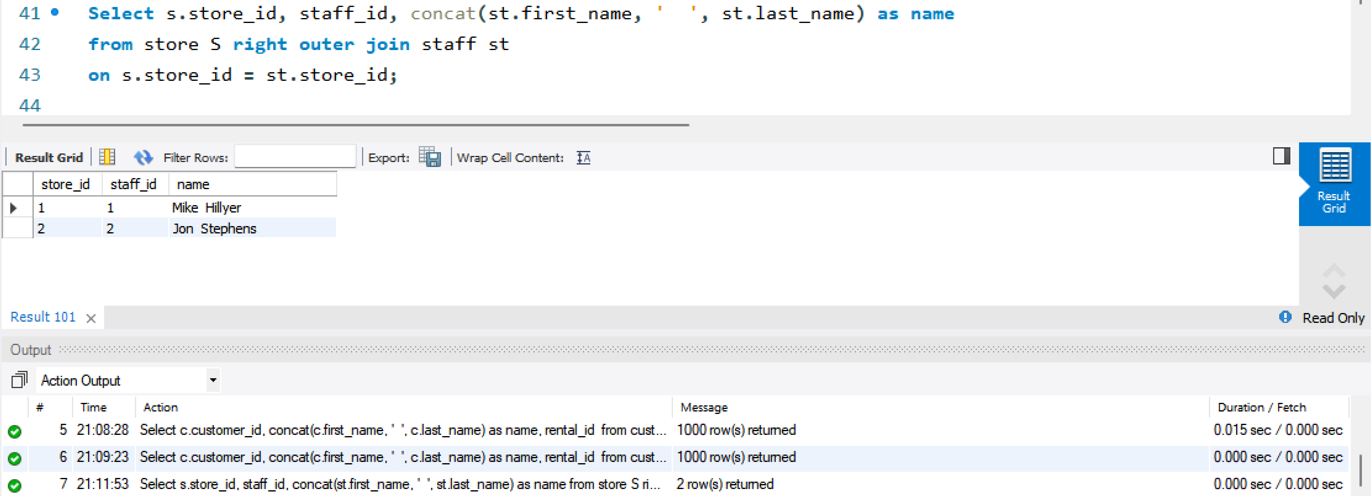

Q4) List customer_name, customer_id, email, rental_id and rental_date. Result should include all customers and rental information

* **Screenshot of MYSQL query & results as shown below for Q4):**

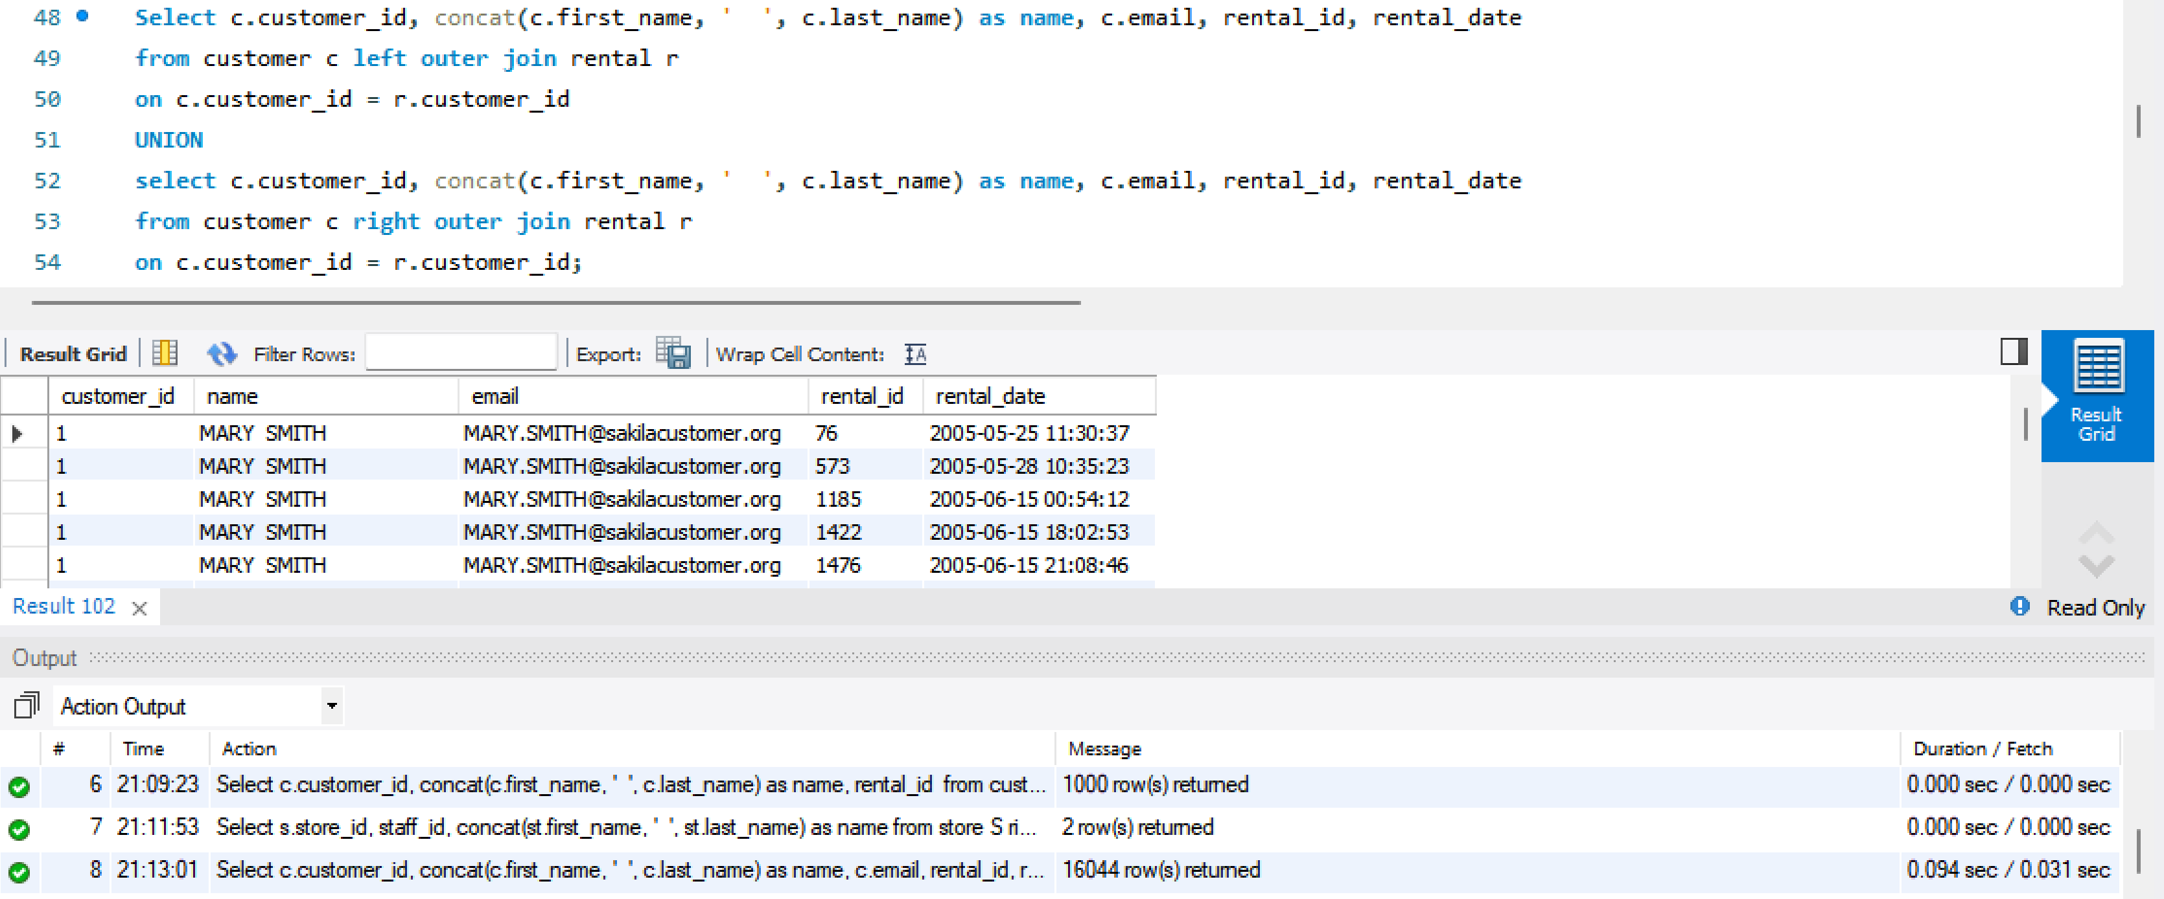

Q5) List customer_name, customer_id, address, rental_id, rental_date and store_id information

* **Screenshot of MYSQL query & results as shown below for Q5):**

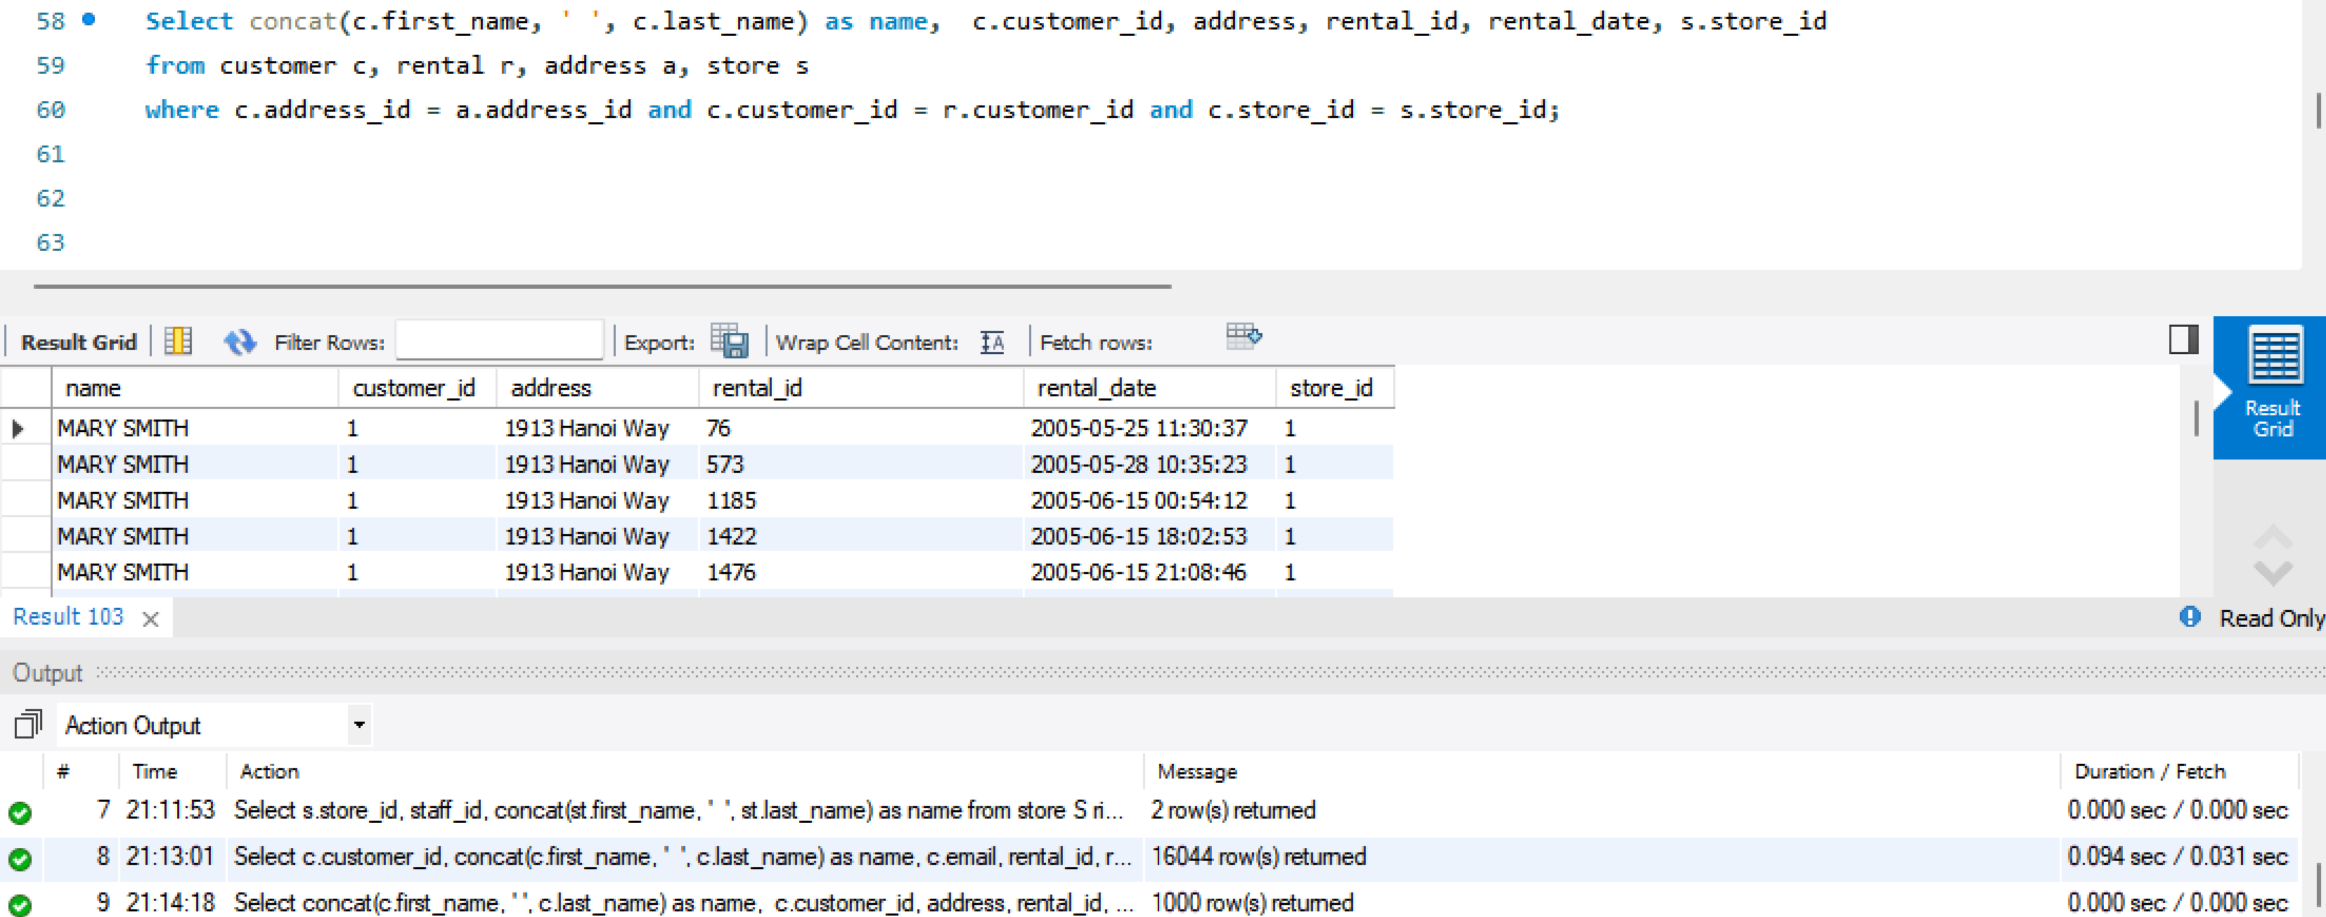

Q6) Assemble all necessary customer and rental and related store information whose customer_id =374

* **Screenshot of MYSQL query & result as shown below for Q6):**

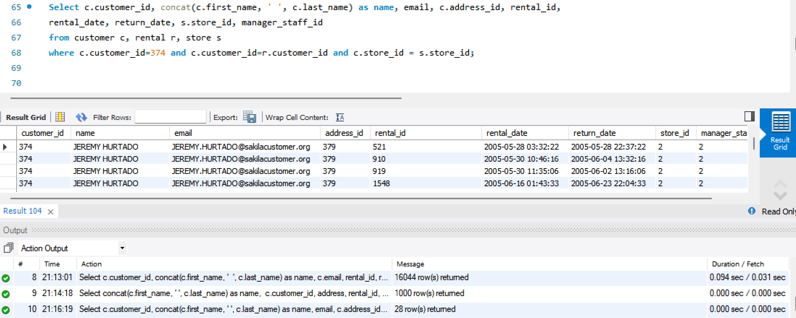

Q7) List out staff_id and name of each staff and name of their managers.

* **Screenshot of MYSQL query & results as shown below for Q7):**

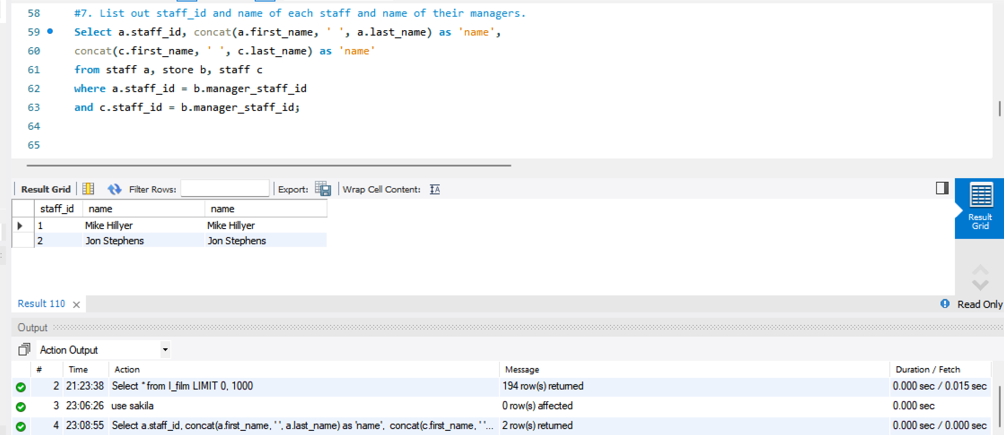

Q8) List out all customers who have rented the movie.

* **Screenshot of MYSQL query & results as shown below for Q8):**

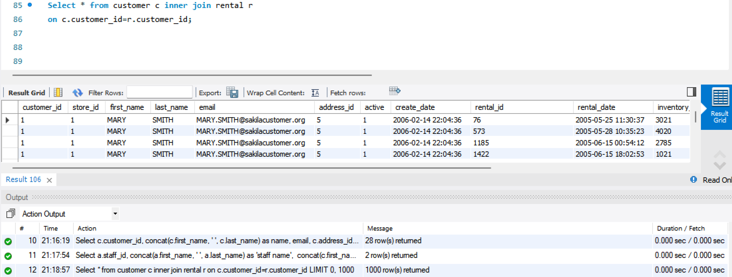

Q9) Create view called “v_film” and include title, descr, release_year and actor_name where rating = ‘G’

* **Screenshot of MYSQL query & result as shown below for Q9):**

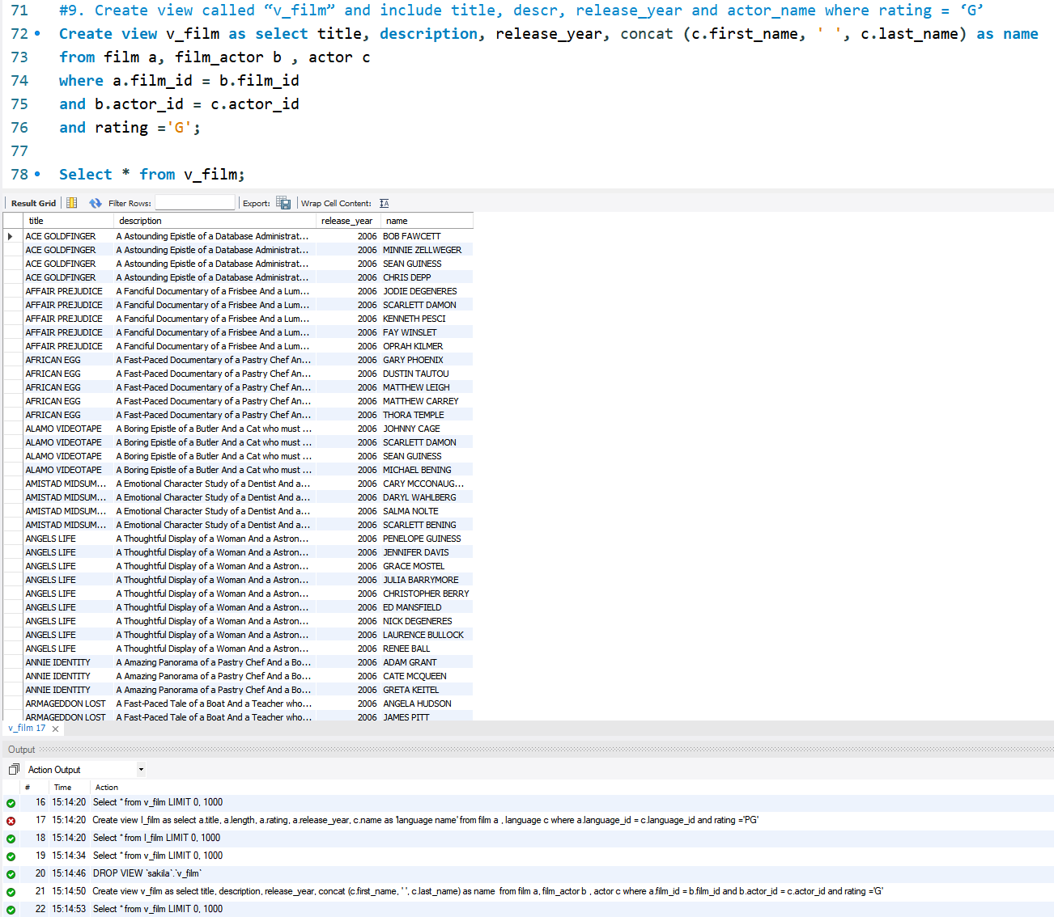

Q10) Create view called “l_film” and include title, length, rating, release_year and language name where rating = PG

* **Screenshot of MYSQL query & result as shown below for Q10):**

